**DAILY ONLINE ACTIVITIES SUMMARY**

|  |  |  |  |  |  |  |  |
| --- | --- | --- | --- | --- | --- | --- | --- |
| **Date:** | **22/05/2020** | | | | **Name:** | **Syed Rabeya Aamir** | |
| **Sem & Sec** | **8th B** | | | | **USN:** | **4AL16CS112** | |
| Online Test Summary | | | | | | | |
| **Subject** | | **BDA** | | | | | |
| **Max. Marks** | | **40** | | **Score** | | **29** | |
| Certification Course Summary | | | | | | | |
| **Course** | **Introduction to Hadoop** | | | | | | |
| **Certificate Provider** | | | **Great learning** | **Duration** | | | **20 mins** |
| Coding Challenges | | | | | | | |
| **Problem Statement:**  **1)** Write a menu program in Python to find Area-Circle, Circumference-Circle, Area- Square, Circumference-Square using functions with menu choice Create seperate functions for each choice of menu | | | | | | | |
| **Status: Solved** | | | | | | | |
| **Uploaded the report in Github** | | | | **YES** | | | |
| **If yes Repository name** | | | | **rabeya** | | | |
| **Uploaded the report in slack** | | | | **YES** | | | |

**Online Test Details**:

Snapshot of test

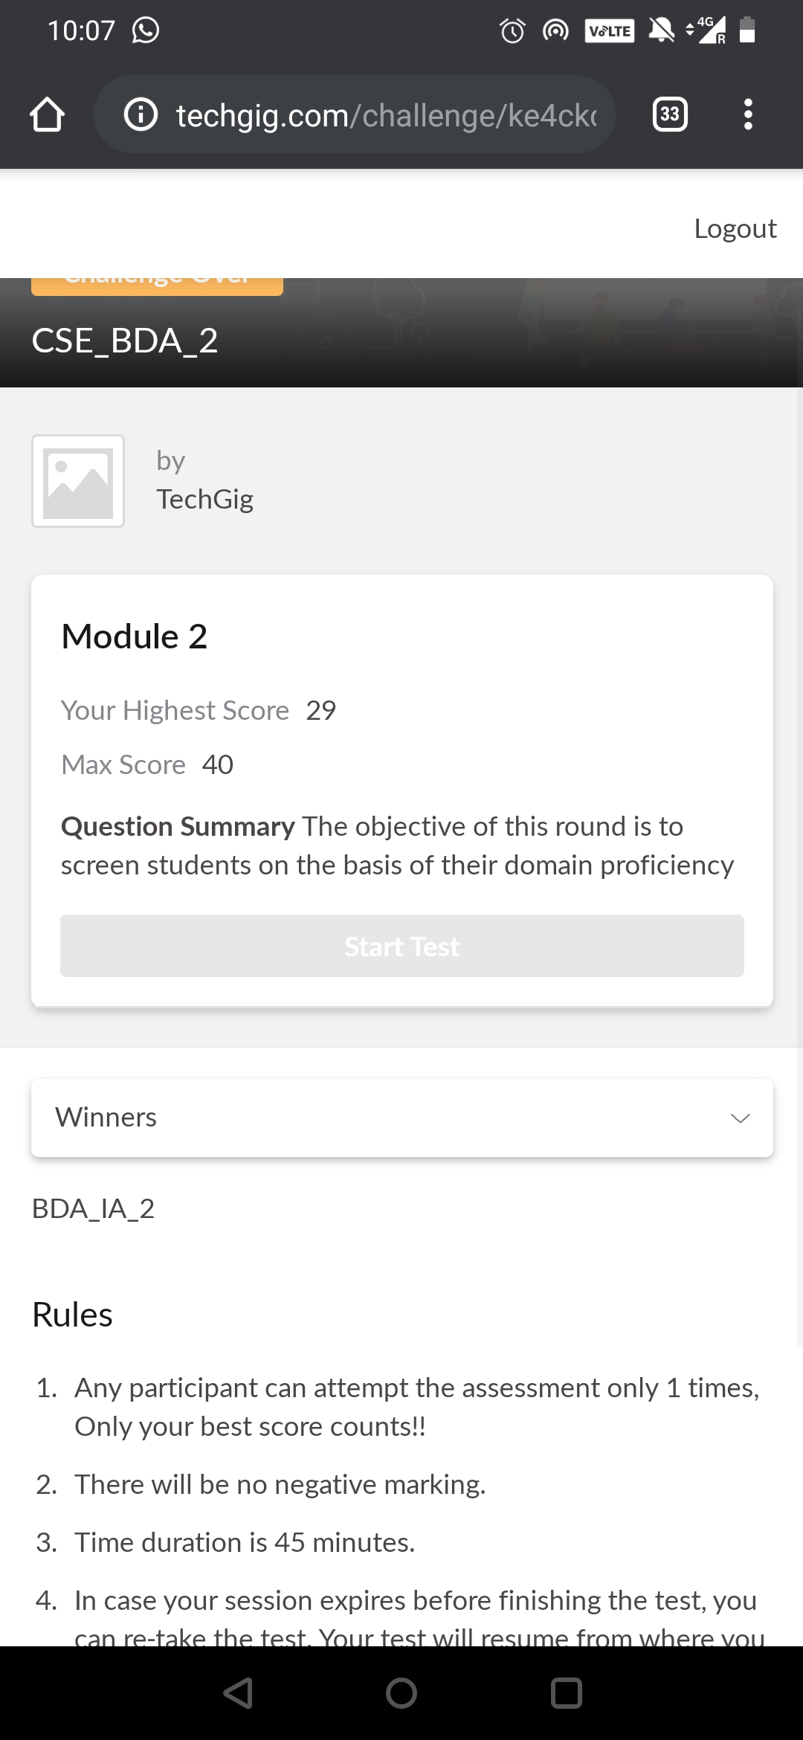

**Certification Course Details:**

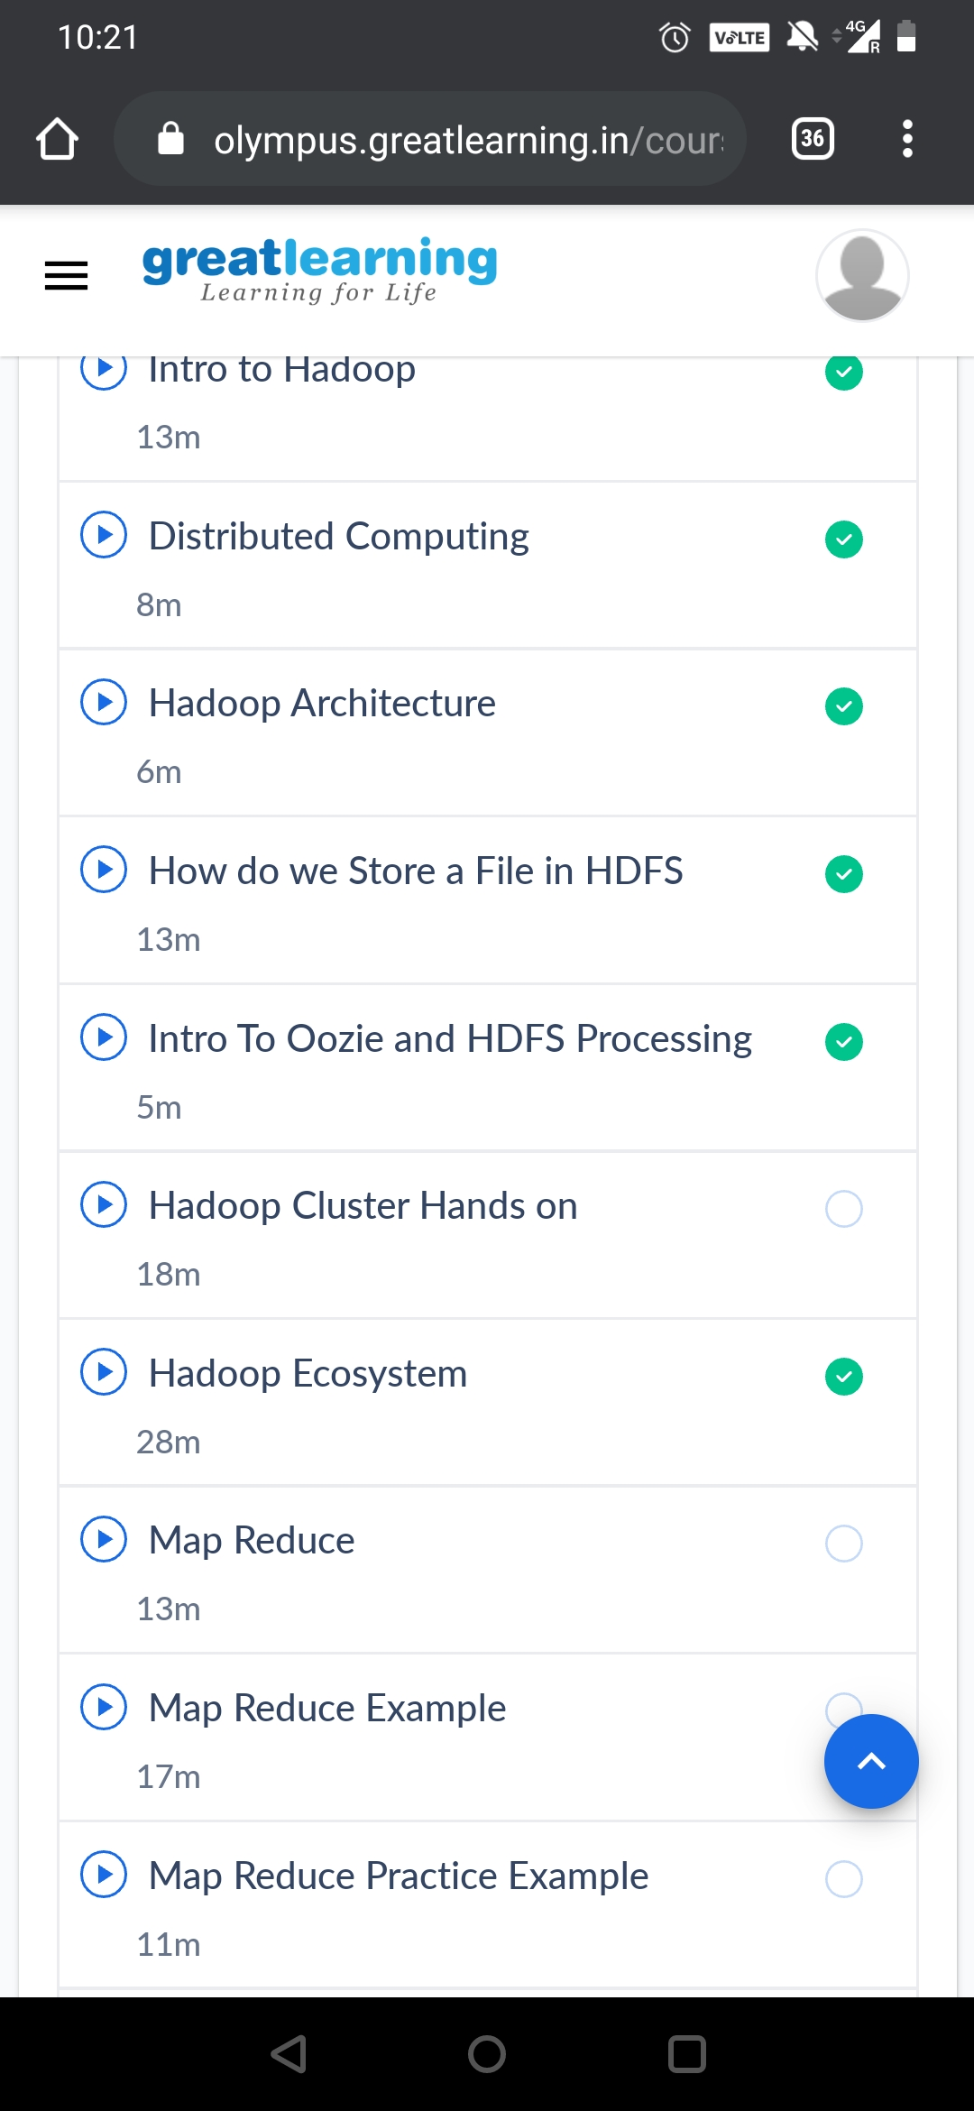

# Store file in HDFS:

# When you load data into HDFS from local filesystem (as shown in your example), HDFS splits it's content into data blocks which are stored in dfs.datanode.data.dir (option from hdfs-default.xml config file) of every machine running Data node daemon. Metadata (inluding name of every file, timestamps and so on) are managed by Name node daemon in separate database. File structure you can see in datanode data dir doesn't have anything to do with actual HDFS filesystem structure.

# Oozi:

# Oozie is a workflow scheduler system to manage Apache Hadoop jobs.Oozie Workflow jobs are Directed Acyclical Graphs (DAGs) of actions. Oozie Coordinator jobs are recurrent Oozie Workflow jobs triggered by time (frequency) and data availability.Oozie is integrated with the rest of the Hadoop stack supporting several types of Hadoop jobs out of the box (such as Java map-reduce, Streaming map-reduce, Pig, Hive, Sqoop and Distcp) as well as system specific jobs (such as Java programs and shell scripts). Oozie is a scalable, reliable and extensible system.

# HDFS Processing:

# Apache Hadoop is a collection of open-source software utilities that facilitate using a network of many computers to solve problems involving massive amounts of data and computation. It provides a software framework for distributed storage and processing of big data using the MapReduce programming mode.

# CODE:

Program no:1

Write a menu program in Python to find Area-Circle, Circumference-Circle, Area- Square, Circumference-Square using functions with menu choice

Create seperate functions for each choice of menu

#main.py

def AreaCircle(r):

return rr

def CircumferenceCircle(r):

return 23.14r

def AreaSquare(b,h):

return b*h

def CircumferenceSquare(h):

return 4h

#pgm.py

from main import*

r=float(input("Enter Radius Of Circle: "))

a=AreaCircle(r)

print("Area Of Circle: ",a)

c=CircumferenceCircle(r)

print("Circumference Of Circle is: ",c)

b=float(input('Enter Base Of Square: '))

h=float(input('Enter Height Of Square: '))

A=AreaSquare(b,h)

print("Area Of Square is: ",A)

CS=CircumferenceSquare(h)

print("Circumference Of Square is: ",CS)